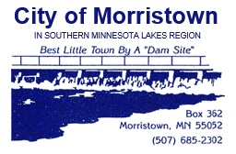
MORRISTOWN ZONING BOARD AGENDA
Regular Meeting, 7:00 p.m.
Thursday, February 20, 2025

1. | CALL TO ORDER:
2. | ADDITIONS/CORRECTIONS: | 201 Bloomer St & 304 Division St. N
3. | PUBLIC HEARING | AMENDING SECTION 152.218 OF THE MORRISTOWN CITY CODE
4. | APPROVAL OF MINUTES:
5. | REQUESTS TO BE HEARD:
6. | COUNCIL ACTION AT LAST MEETING:
A
7. | UNFINISHED BUSINESS:
A
8. | NEW BUSINESS:
A | Zoning Administrator | Review Application
9. | ZONING ADMINISTRATOR’S REPORT:
A |  | See attached report.
10. | BOARD DISCUSSION & CONCERNS:
11. | ADJOURNMENT:
12. | NEXT MEETING: | Thursday, March 20th, 2025 – 7:00 p.m.

