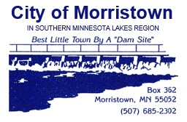
MORRISTOWN CITY COUNCIL MEETING AGENDA
Special Meeting
Wednesday, October 23, 2024

1. | Call to Order:
7. | NEW BUSINESS:
A | Assessments | Certify 2024 Street Assessments
10. | ADJOURNMENT:
11. | NEXT MEETING: | Monday, November 4, 2024 – 7:00 p.m.

