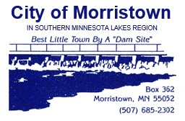
MORRISTOWN ZONING BOARD AGENDA
Regular Meeting, 7:00 p.m.
Thursday, July 18th, 2024

1. | CALL TO ORDER:
2. | ADDITIONS/CORRECTIONS:
3. | CORRECTIONS OF MINUTES:
4. | REQUESTS TO BE HEARD:
5. | COUNCIL ACTION AT LAST MEETING:
 |  | None
6. | UNFINISHED BUSINESS:
A | Driveway | Driveway work at 105 Franklin St. E – Tony to explain
7. | NEW BUSINESS:
 | Jacob Dahle | New construction
8. | ZONING ADMINISTRATOR’S REPORT:
A |  | See attached report.
9. | BOARD DISCUSSION & CONCERNS:
10. | ADJOURNMENT:
11. | NEXT MEETING: | Thursday, August 15th, 2024 – 7:00 p.m.

