City of Morristown
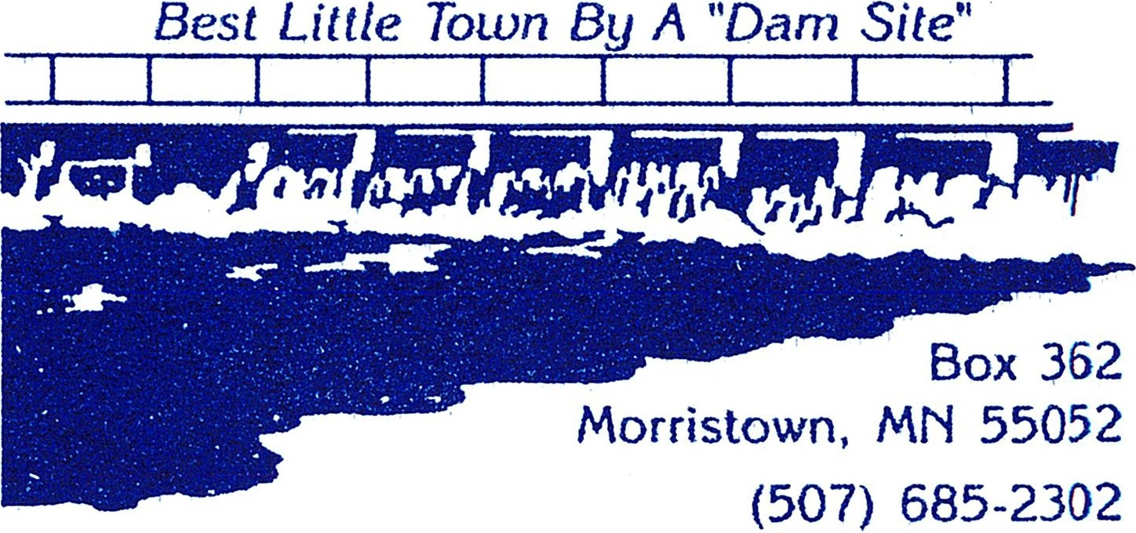
IN SOUTHERN MINNESOTA LAKES REGION

MORRISTOWN EDA MEETING MINUTES
Regular Meeting 6:00 p.m.
Monday, April 1, 2024

Board Members Present: Chairman Steve Nordmeier, Chuck Larsen, Loren Dahle, Kurt Wolf, and Leon Gregor
Board Members Absent: None
Others Present: City Administrator Ellen Judd

- Call to Order: The EDA Committee meeting was called to order by Chairman Steve Nordmeier, on Monday, April 1, 2024 at 6:03 p.m., in the City Council Chambers, at 402 Division Street South.
- Additions/Corrections to Agenda: To discuss under new business Andy Valentyn’s build
- Additions/Corrections of Meeting Minutes:
Motioned by Larsen, seconded by Wolf, and was carried unanimously to approve the minutes from last meeting.
- Comments and Suggestions from Citizens Present: None
- Unfinished Business: None
- New Business:
  - Discuss Grant loan application
Motioned by Chuck, seconded by Wolf, and was carried unanimously to leave the grant loan application the same.
B. Andy Valentyn Property/Build
Motioned by Chuck, seconded by Wolf, and was carried unanimously to keep the industrial area as is.
- Authority Discussion and Concerns: None
- Adjournment:
  - Motion by Dahle, seconded by Wolf, and was carried unanimously to adjourn at 6:10 p.m.
- Next Meeting: Monday, July 1, 2024, at 6:00 p.m.

