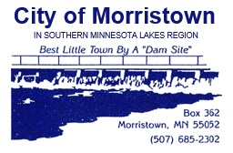
MORRISTOWN CITY COUNCIL MEETING MINUTES
Work Session, 7:00 p.m.
Wednesday, August 21, 2024

Members Present: |  | Tony Lindahl (Mayor), Linda Murphy, Joe Caldwell, Leon Gregor, Jake Golombeski
Members Absent: |  | None
Others Present: |  | Ellen Judd (City Administrator), Cassie Eldeen (City Clerk)
7. | NEW BUSINESS:
A | Budget and Levy |  | City Administrator presented preliminary 2025 budget and levy options to the Council. The Council reviewed different options and inquired about some specific line items and how different options could possibly work for the city. At the end of the discussion, the council was in agreement with a preliminary budget for 2025.
11. | NEXT MEETING: |  | Tuesday , September 3rd, 2024 – 7:00 p.m.

 |  | Approved:
Attested: |  |  | Mayor, Tony Lindahl
 | City Clerk, Cassie Eldeen

